A non refundable Deposit of
£10.00
Per person is required with this booking form.
Travel Insurance
We recommend that Travel Insurance is taken. IOW Tours ltd can arrange this for you ring for details
I enclose a Deposit or
Full Payment* of £
for …. Persons (delete as applicable)
or
Debit my Access/Visa
Switch / Delta Account
Card Number
…………………
…………………
Switch/Delta Only, Issue Number……….
Expiry Date
………..……… Signature
………………..
Cardholders Name……………
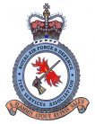

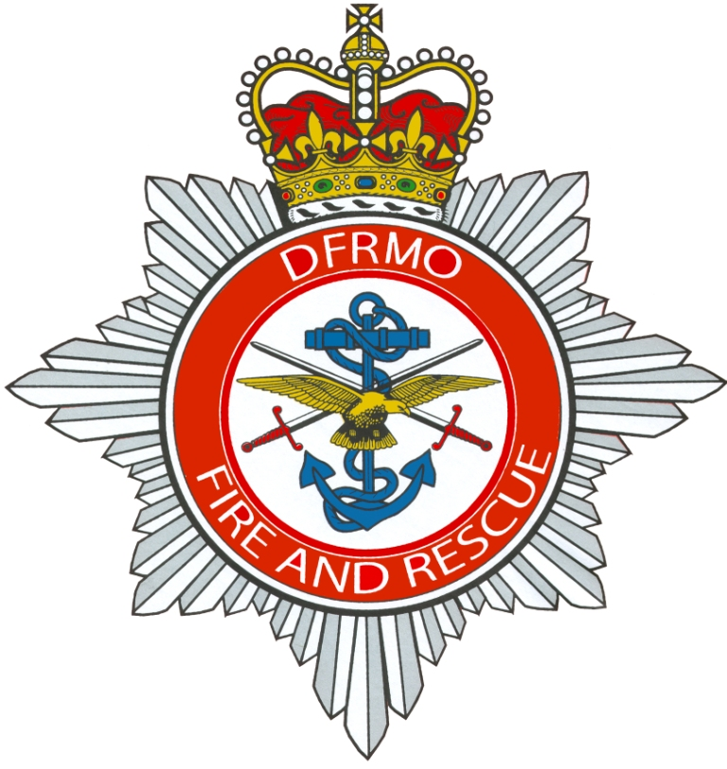

RAF&DFSA Social Weekend
Booking Form Spring 2016
ALL HOLIDAYS ARE SUBJECT TO AVAILABILITY AT THE TIME OF BOOKING. SPACE IS NOT GUARANTEED UNTIL THE NON-REFUNDABLE DEPOSIT IS PAID.
At the

Holiday Inn Garden Court

Sandy, Bedford

Friday 11th March to Monday 14th March 2016

Your Informal Weekend Holiday includes:-
3 nights half board accommodation
All rooms en suite with hospitality tray and colour TVs
Sole use of the Bedford suite for Gala Dinner
1st class entertainment on Gala Night
Wine reception on gala night
No Single room Supplement (limited available)

Just £159 per person for 3 nights
£124 per person for 2 nights
Gala Dinner Only £35.00 per person

Optional Excursions- please tick below. We will add cost to invoice
Saturday – Day Tour to Bletchley Park & the Shuttleworth Collection - £35.00 per person
Sunday Trip – RAF Hendon - £9.00 per person

Personal Details
Name………………………………………………………………………………………
Address………………………………………………………………………………………………………………………………………………………………………………….
Post Code………………
Telephone Number including Dialling code…………………………………………….
Your Party
Total Number of Persons………..
Names of other guests on this form;………………………………………………………
……………………………………………………………………………………………...
…………………………………………………………………………………………...………………………………………………………………………………………………...
Rooms required: Double….……...Twin………….Single…..…….Family……….….…
Special requests such as diet, walking difficulties etc. …………………………………
…………………………………………………………………………………………….
All prices are inclusive of VAT @20%
All queries to Shirley or Vanessa at IOW Tours 01983 405116
RAF&DFS Association Representative Neil Slade 07825655023
Cheques payable to Isle of Wight Tours Ltd
Please return this form with your remittance to: Isle of Wight Tours Ltd,
3 New Road, Lake, Sandown, Isle of Wight, PO36 9JN. Telephone 01983 405116

All bookings subject to our terms and conditions see enclosed

