A non refundable Deposit of
£10.00
Per person is required with this booking form.
Travel Insurance
We recommend that Travel Insurance is taken. IOW Tours ltd can arrange this for you ring for details
I enclose a Deposit or
Full Payment* of £
for …. Persons (delete as applicable)
or
Debit my Access/Visa
Switch / Delta Account
Card Number
…………………
…………………
Switch/Delta Only, Issue Number……….
Expiry Date
………..……… Signature
………………..
Cardholders Name……………
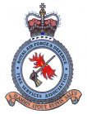

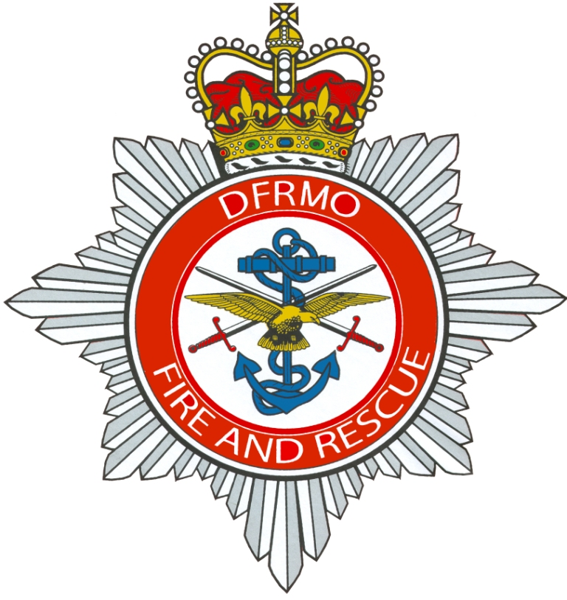

RAFDFSA Reunion & AGM Weekend
Booking Form October 2014
ALL HOLIDAYS ARE SUBJECT TO AVAILABILITY AT THE TIME OF BOOKING. SPACE IS NOT GUARANTEED UNTIL THE NON-REFUNDABLE DEPOSIT IS PAID.
At the

4* Sketchley Grange Hotel

Hinckley, Leicestershire

Friday 16th October to Monday 19th October 2015
Your Reunion Weekend includes:-
2 or 3 nights half board accommodation
All rooms en suite with hospitality tray and colour TVs
Sole use of function suite for Gala Dinner & AGM
1st class entertainment on Gala Night
Wine reception on gala night
Free use of leisure facilities
No Single room Supplement on a limited amount of single rooms
Just £169 per person for 3 nights
£134 per person for 2 nights

Optional Excursion to Coventry on Saturday £7.00 per head
Please tick ..... if you wish to go. We will add this to your invoice.
Optional Excursion on Sunday to Stratford upon Avon inc. boat trip £14.00 per head.
Please tick .......if you wish to go. We will add the cost to your invoice.

Personal Details
Name………………………………………………………………………………………
Address………………………………………………………………………………………………………………………………………………………………………………….
Post Code………………
E Mail Address ...................................................................................................................
Telephone Number including Dialling code…………………………………………….
Your Party
Total Number of Persons………..
Names of other guests on this form;………………………………………………………
……………………………………………………………………………………………...
…………………………………………………………………………………………...………………………………………………………………………………………………...
Rooms required: Double….……...Twin………….Single…..…….Family……….….…
Special requests such as diet, walking difficulties etc. …………………………………
…………………………………………………………………………………………….
All prices are inclusive of VAT @20%
All queries to Shirley or Vanessa at IOW Tours 01983 405116
Cheques payable to Isle of Wight Tours Ltd
Please return this form with your remittance to: Isle of Wight Tours Ltd,
3 New Road, Lake, Sandown, Isle of Wight, PO36 9JN. Telephone 01983 405116
All bookings subject to our terms and conditions see enclosed

