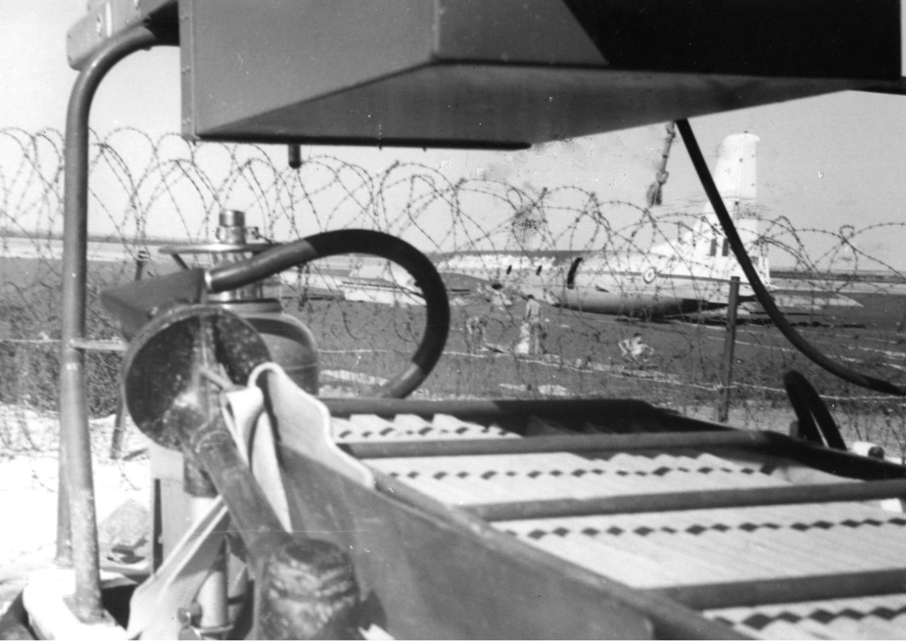
KHORMAKSAR, ADEN 1967

This photograph was taken during the last weeks of occupation in Aden, during the early hours of the morning at the runway overshoot of RAF Khormaksar. The previous night at approximately 2300 hrs an RAF Britannia attempting to land with no runway lights (because of the threat of terrorist fire) overshot the runway, crash landing in the sea between the perimeter fence and the causeway road, clearing the barbed wire in doing so. On arriving at the scene, the crash crew led by Sgt Johnny Munger set up search lights and cut through the fence before wading waist deep in mud and water in order to carry out rescue from the aircraft. When the RAF firemen entered the aircraft they found that all the 28 passengers and 4 crew had made an escape from the other side exit and were making there way, in the dark, through the mud and water towards the headlights of the arriving fire tenders. All photography was banned at what turned out to be the last major aircraft incident attended by RAF firemen in Aden; hence this picture was taken secretly (like many others) through the rear of the crash rescue land rover. (ACRT). Initially set up as a British Imperial Base to protect shipping in 1839, Aden ceased to exist as a protectorate only weeks later when the final withdrawal of the British forces took place on November 29th 1967. Those firemen who were lucky enough to be present over the final weeks of the withdrawal were witness to an air transport operation bigger than anything since the Berlin airlift ably assisted by 25 ships of the Royal Navy including three aircraft carriers HMS Eagle, Bulwark and Hermes all anchored offshore. Of course, we couldn’t see the ships from the airfield, only the row after row of helicopters going back and forth with their cargo slung below them making their way out to sea where the three aircraft carriers lay at anchor. An historical sight and time of events that I and I’m sure my old mates will never forget.

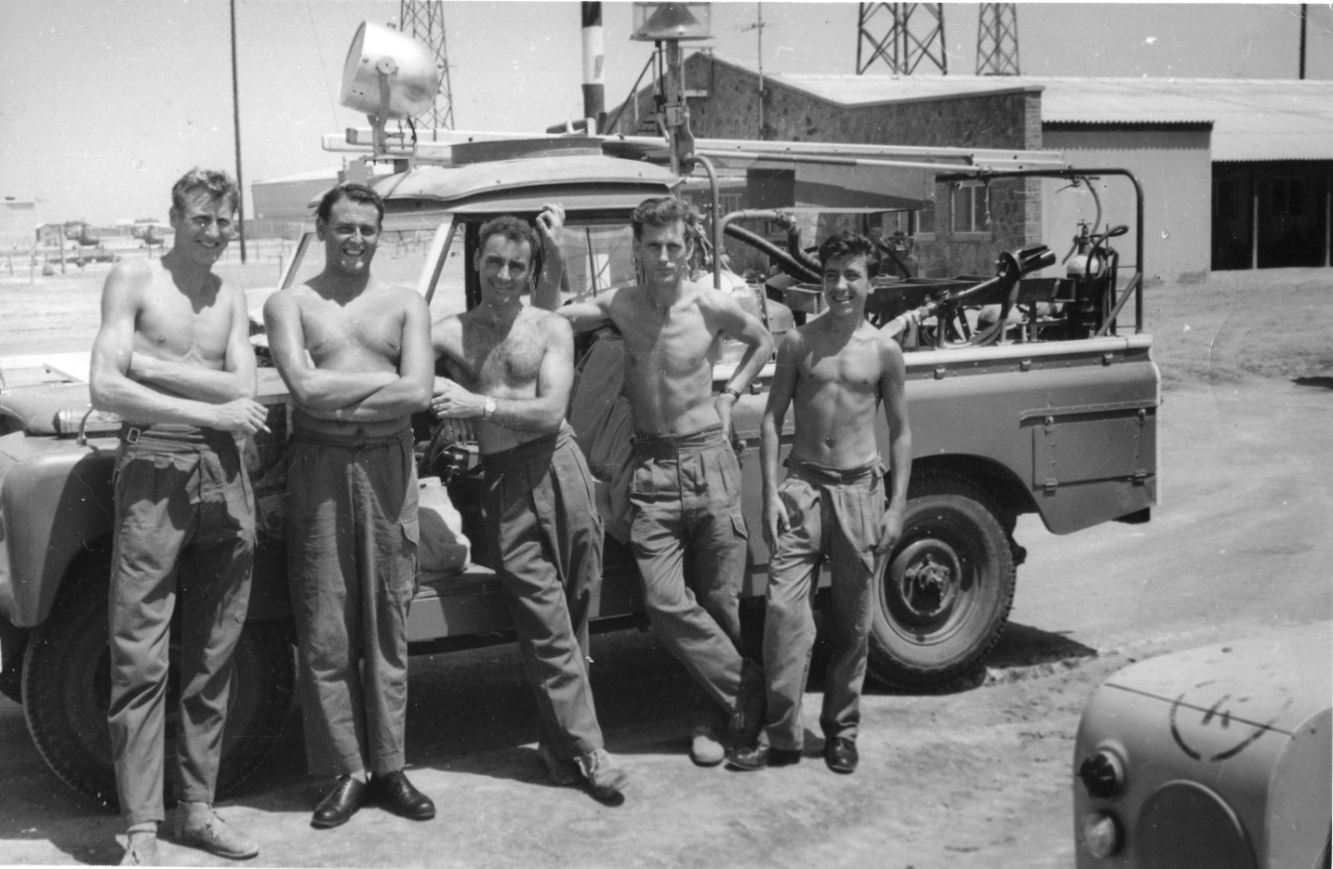

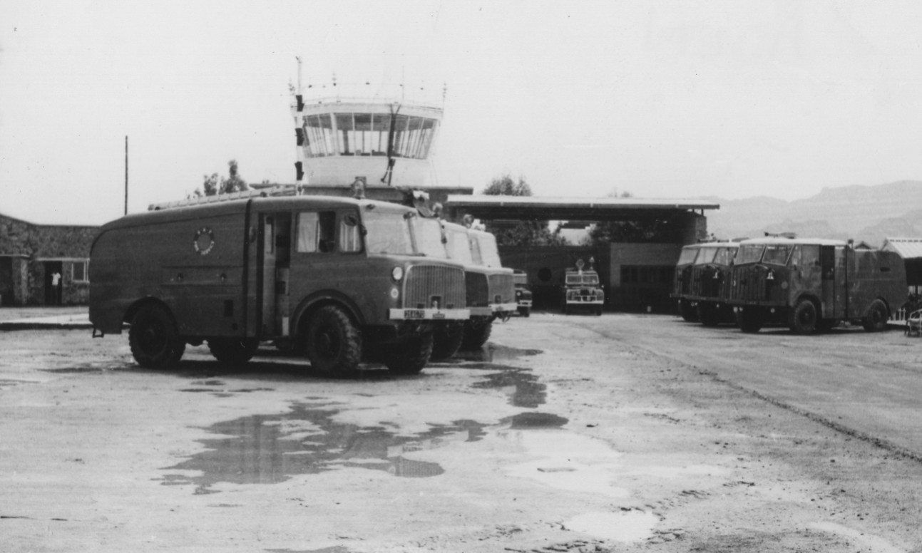
THE CRASH BAYS AT RAF KORMAKSAR

RAF fire tenders including DP1`s, DP`2s, and MRK 5As, in front of the crash bays and air traffic control, photographed the day after a rare downpour of rain. Two and half inches of rain fell on that one day and was as much as had fallen over several previous years. The surrounding rocky terrain of the infamous Crater district can be seen in the background.

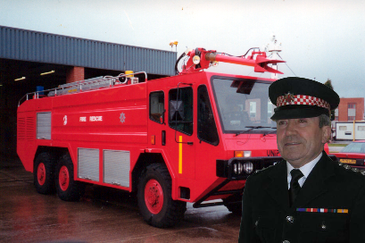
Terry Sedgwick in a new era of technology, a different uniform but doing the same job.

